**Project Design Phase-II**

**Technology Stack (Architecture & Stack)**

| Date | 15 October 2022 |
| --- | --- |
| Team ID | PNT2022TMID53272 |
| Project Name | Project - A Novel Method for Handwritten Digit Recognition System |
| Maximum Marks | 4 Marks |

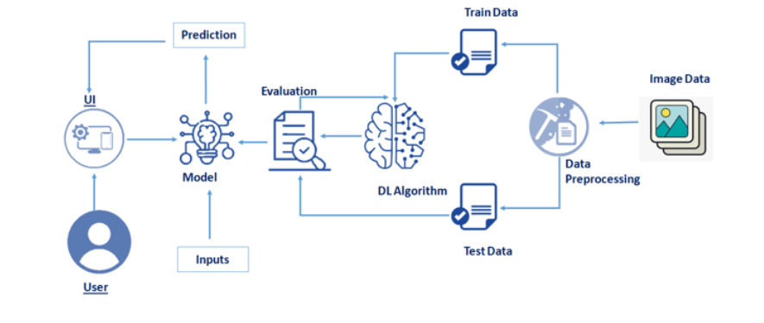

**Table-1 : Components & Technologies:**

| **S.No** | **Component** | **Description** | **Technology** |
| --- | --- | --- | --- |
|  | User Interface | Prediction page where we can choose the image and predict the output | HTML, Flask, Tensorflow |
|  | Application Logic-1 | Image is sent to the Flask backend for prediction | Flask, Tensorflow |
|  | Application Logic-2 | Image is processed using a CNN and a prediction is made | Flask, Tensorflow |
|  | Application Logic-3 | The prediction is sent back to the user and displayed | Flask, Tensorflow |
|  | Cloud | Model is trained in IBM Cloud | IBM Cloud |
|  | Machine Learning Model | Convolutional Neural Network | Tensorflow, Python |
|  | Infrastructure (Server / Cloud) | Model is trained and application is hosted in IBM Cloud | IBM Cloud |

**Table-2: Application Characteristics:**

| **S.No** | **Characteristics** | **Description** | **Technology** |
| --- | --- | --- | --- |
|  | Open-Source Frameworks | Tensorflow, Flask | Technology of Opensource framework |
|  | Security Implementations | List all the security / access controls implemented, use of firewalls etc. | e.g. SHA-256, Encryptions, IAM Controls, OWASP etc. |
|  | Scalable Architecture | Justify the scalability of architecture (3 – tier, Micro-services) | Technology used |
|  | Availability | Justify the availability of application (e.g. use of load balancers, distributed servers etc.) | Technology used |
|  | Performance | Design consideration for the performance of the application (number of requests per sec, use of Cache, use of CDN’s) etc. | Technology used |

**References:**

[**https://c4model.com/**](https://c4model.com/)

[**https://developer.ibm.com/patterns/online-order-processing-system-during-pandemic/**](https://developer.ibm.com/patterns/online-order-processing-system-during-pandemic/)

[**https://www.ibm.com/cloud/architecture**](https://www.ibm.com/cloud/architecture)

[**https://aws.amazon.com/architecture**](https://aws.amazon.com/architecture)

[**https://medium.com/the-internal-startup/how-to-draw-useful-technical-architecture-diagrams-2d20c9fda90d**](https://medium.com/the-internal-startup/how-to-draw-useful-technical-architecture-diagrams-2d20c9fda90d)